Crack The Covid – 19 Crisis

By NASSCOM Future Skills and IBM

**TEAM NAME: MSR (ECE/IIA):** **M**icro **S**olution **R**eady

Title of the Proposed Project: ***Physical Distancing Using Arduino***

**Solution Architecture:**

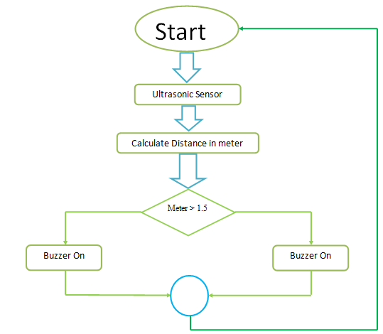

**Source code:**

#include<stdio.>

Void main( )

//defines pin number

Constant int trig pin=2;

Constant int echo pin=3;

//defines variable

Long durantion;

Int distance;

Void setup ( )

{

Pin mode(trig pin , OUTPUT);

Pin mode(echo pin,INPUT);

Serial.begin(9600);

Pin mode(11,OUTPUT);

}

Void loop

{

Clear the trig pin

digital write( trig pin,low);

Delay micro seconds(2);

//Set the trig pin on HIGH state for

digital write(trig pin,HIGH):

delay micro seconds(10);

digital write(trig pin,LOW);

//Reads the echo pin,returns the

duration=pulse In(echo pin,HIGH)

//Calculating the distance

distance =duration*0.034/2;

//Prints the distance on the serial

Serial print("distance:");

Serial.println(distance);

if (distance<100)

{

digital write(11,HIGH);

}

else

{

digital write(11,LOW);

}

}